**ABSTRACT**

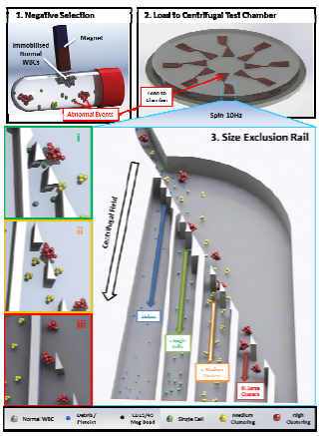

***Figure 1: Full Protocol*** *(Top) Negative Selection and 3D representation of a full disc equipped with 8 test chambers. (Lower Right) The size based segregation section of the test chamber showing binning of single, medium and large clusters. (Lower Left) Zoom of bin gates. For clarity, a chamber with only four bins is represented.*

In addition detecting circulating tumour cells (CTCs) in blood, the presence of multi-cellular clusters has recently been identified to carry further information pertaining to patient outcome. We present a label-free method of measuring the range and load of clusters in a blood sample using a size-exclusion rail operated by centrifugal microfluidics. A negative selection strategy first enriches clusters from a whole blood sample; these clusters are then processed along the rail where they resolve to a series of collection bins according to size. Analysis of the occupancy of these bins then provides metrics on the cancer-cell load carried in the blood.

**INTRODUCTION**

There is increasing evidence that in addition to their presence, the propensity of CTCs to form multi-cellular clusters bears significant information of cellular resistance to chemotherapy and overall prognosis [1]. Both, indivi-dual CTCs and clusters thereof, occur when cellular events detach from the site of a primary tumour and enter the blood stream. We here define an event as either a single cell or a cluster. These CTCs may then promote metastasis.

A number of microfluidic systems isolate candidate CTC events by using a positive detection strategy where cells with selected epitopes are targeted and manipulated *via* the binding of reagents specific to the epitopes of interest [2, 3]. While such strategies can be very sensitive to such cells of interest, the inherent heterogeneity within CTC populations can limit the use of the strategy as there are no known epitopes that are common to all CTCs identified. For example, EpCAM expressing cells in blood are commonly used in commercial positive isolation strategies for the identification of CTCs. However, some CTCs do not express EpCAM; and indeed, in many carcinomas EpCAM is under-expressed or even absent [4]. Similarly, enrichment strategies by flow-based filtration are susceptible to clogging [5]; also sizing of co- localized clusters on a filter as well as subsequent removal of target cells tends to be challenging. The technique presented here alleviates these caveats by combining surface biomarker purification and differential size filtration to directly characterize the clinically relevant cluster load in blood using a two-stage centrifugo-microfluidic strategy (Fig. 1).

The first stage involves an off-chip blood processing step. When a whole blood sample is to be tested, the red blood cells (RBCs) are first lysed using standard hypotonic lysis protocol. Following this, a negative isolation strategy is used to overcome the inherent phenotypic heterogeneity of CTCs. Here, the white blood cells (WBCs) are incubated with a mixture of CD15 and CD45 super-paramagnetic beads which bind to all naturally occurring WBCs while abnormal events (candidates for CTCs or CTC-based clusters) lack expression of CD15 or CD45 and therefore stay unbound. Healthy WBCs are then gently removed from the solution by placing the tube in proximity to a magnet (Fig. 1, top left). The cellular events that remain in solution are considered to be abnormal events. These events are then placed into the centrifugal test chamber (Fig. 1, top right) where they are sorted according to size. The sorting is carried out by a rail that spans the top of eight discrete collection bins. The apertures in the rail that gates the top of each bin increase in size the further along the rail an event progresses, with the larger events resolving to later bins. Examination of the filling of the bins then provides an indication of the range and load of abnormal cell clusters harboured in the original whole blood sample.

The entire, dead-end microfluidic chamber is first fluidically primed so that the system operates in stopped- flow sedimentation mode. The isolated abnormal events are loaded to the Sample Loading chamber *via* the loading port and the disc is spun at 10 Hz. On exiting the loading chamber, events are guided along a Size Exclusion Rail which is slightly inclined against the direction of the centrifugal field (Fig. 2, orange box). This rail is composed of flat-edged pillars, with the interspersed gaps that gate the entry to the underlying bin progressively increasing in size. Bins are oriented in the radial direction so events penetrating the rail centrifugally sediment into the bin. The gate size increases from initially 4.7 μm (isolates debris and highly deformable cells) to 130 μm in the last of the eight bins. The events then resolve by the centrifugal force to the base of the collection bins where they can be observed by microscopy.

**METHODOLOGY**

### CHIP MANUFACTURE

The microfluidic discs used in this paper were formed from polydimethylsiloxane (PDMS; Dow Corning, MI) mixed at a ratio of 10:1 base and curing agent. The procedures for making a master and for securing the co- rotating magnet in the PDMS have been described in detail elsewhere [6-67]. Loading holes and vents were defined in the PDMS at appropriate locations using a dot punch. The PDMS slab containing the microfluidic features was placed on a 100-mm glass base disc and allowed to bond for 1 min. Finally, the glass / PDMS disc was mounted to a PMMA base. To prime the microchannels and structures, the disc was placed under vacuum for at least 1 hour, following which a large drop of priming buffer (phosphate-buffered saline [PBS] pH 7.4, 0.1% w/v bovine serum albumin [BSA], 1 mM EDTA) was immediately placed on the surface of the PDMS, covering the sample ports of the loading chamber. Degas-driven flow then primed the channels.

**SYSTEMDESIGN**

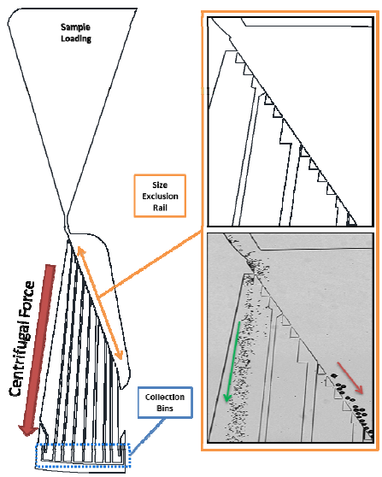

***Figure 2: Schematic of the Size Excl sion Rail.*** *(Left) Schematic of a full test chamber. (Orange border) The Critical Size Exclusion Rail during processing of 5 μm (green arrow) and 40 μm (red arrow) beads. For clarity, beads are shown rather than cells.*

**BLOOD PROCESSING AND CELL CULTURE**

Blood was extracted directly from healthy donors *via* intravenous extraction. To prevent coagulation samples were drawn into tubes containing EDTA. Blood was isolated and prepared fresh, directly before experimental use.

HL60, colo794 and sk-mel28 cells (DSMZ, Braunschweig, Germany) were cultured in 75cm2 flasks in RPMI 1640 media, with 10% un-inactivated foetal bovine serum, 100 U mL-1 penicillin, and 100μg mL-1 streptomycin. Cultures were maintained at 37 °C with 5% CO2. Where indicated, cells were fluorescently stained with NucBlue Live Cell Stain (Life Technologies) according to the instructions of the manufacturer.

Experimental samples were prepared by spiking 1000 cellular events into 1 ml of whole blood. Un-spiked whole blood was used as a control sample. The RBCs were lysed by adding 1 ml whole blood to 9 ml of hypotonic lysis buffer (BD Biosciences, Franklin Lakes, USA) and incubated for 15 minutes. WBCs were then isolated by centrifugation at 200 x g for 5 minutes and resuspension in 1 ml of priming buffer. CD45 (80 µl) and CD15 (16 µl) Dynabeads (Life Technologies) were added and incubation was carried out in a 2 mL Eppendorf tube with rotation for 10 minutes. Negative isolation was performed by slowly bringing a permanent NdFeB magnet into proximity to the incubation tube while rocking the tube horizontally. Cells expressing CD15 or CD45 were immobilized to the side of the tube and the remaining cellular events were placed into a new tube and centrifuged at 500 x g for 5 minutes to pellet. The final pellet was resuspended in 40 µl and 5 µl of this sample was loaded to each of the chambers in the disc. The disc was spun counter-clockwise at 10 Hz for 30 minutes. The resolution of material to the collection bins was observed by both bright-field and fluorescent microscopy.

**RESULTS**

To test the ability of the size exclusion rail to show the range of cluster sizes inherent to a spiked cell line in blood, we first showed that the cell lines had a propensity to cluster; and to measure the range and extent of the clustering. All three cell lines (HL60, colo794, and sk- mel28) were observed under light microscopy and each event observed was scored according to the number of cells within the event (Fig. 3).

In Figure 3, HL60 cells occur primarily as single celled events, with little or no propensity to form clusters. A low level of clustering was observed for colo794 cells, where 78% of events existed as single cells but clusters com- posed of up to 4 cells were observed. Finally, sk-mel28 cells showed a high range of cluster sizes from one to more than eight cells, with less than 22% contribution of single celled events.

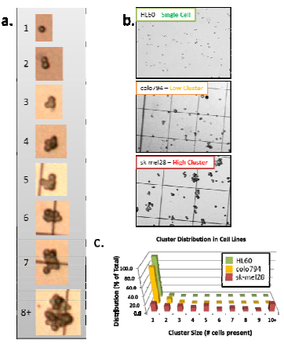

***Figure 3: Cell cluster distribution.*** *a) Examples of cell clusters of indicated sizes. b) Images of cell lines that present as single, low clustering, and high clustering configurations. c) Distribution of clusters in all three lines is shown in the 3D histogram.*

We then spiked cancer cells into whole blood, processed as described, and recorded the distribution of cellular events in the collection bins using fluorescence microscopy (Fig. 4). The occupancy distribution of the bins closely correlated with the range of cluster sizes intrinsic to the specific cell line. For example, HL60 cells localized almost exclusively to the first bin, while sk- mel28 events were distributed across the eight bins (Fig. 3), correlating with the tendency of these popu- lations to form events ranging from 1 to more than 8 cells (Figs. 4 and 5). Loss of larger clusters through steric restriction was minimal, underpinning an advantage over flow-based filtration methods which may be clogged by larger clusters. Also of note, HL60 and sk-mel28 cells are known to be EpCAM+ and EpCAM-, respectively. Positive isolation systems that target EpCAM as the primary marker of CTCs would hence have failed to identify and enrich the sk-mel28 cells. The negative isolation protocol used in the presented strategy had no difficulty isolating all spiked cell lines regardless of their phenotype.

**Normal Blood**

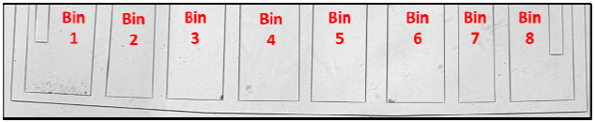

**Spiked Blood (sk-mel28)**

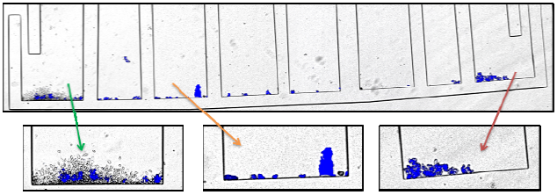

***Figure 4: Image of size bins following processing of normal blood and blood spiked with high clustering sk- mel28 cells.*** *In normal blood, only the first bin is occupied with debris and platelets. Spiked blood occupies bins according to the distribution of cluster sizes inherent to the spiked cell line. Cells have been stained using the NucBlue nuclear fluorescent stain for visual clarity.*

**CONCLUSIONS**

In conclusion, we have quantified the differential propensities of cancer cell lines for clustering by a novel 2-stage, continuous centrifugal sedimentation strategy in stopped-flow mode. The chip-based results were verified against microscope-based read-out. Current work is directed towards on-disc integration of the negative isolation purification protocol on the upstream side in a sample-to-answer point-of-care device.

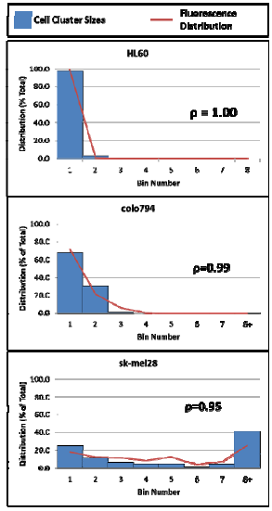

***Figure 5: Data analysis.*** *Correlation analysis of cell clustering (bar charts, data same as the bar chart data in figure 3c) and fluorescent signal distribution (red line graph) in the bins after sample processing. Correlation values between expected cell cluster sizes and measured distribution across the bins are shown.*

**ACKNOWLEDGEMENT**

This work was supported by Enterprise Ireland under grant No. CF 2011 1317, the ERDF and the Science Foundation Ireland under grant No 10/CE/B1821.

**REFERENCES**

[1] Jian-Mei Hou, Matthew G. Krebs, Lee Lancashire, Robert Sloane, Alison Backen, Rajeeb K. Swain, Lynsey J.C. Priest, Alastair Greystoke, Cong Zhou, Karen Morris, Tim Ward, Fiona H. Blackhall and Caroline Dive. Clinical Significance and Molecular Characteristics of Circulating Tumor Cells and Circulating Tumor Microemboli in Patients With Small-Cell Lung Cancer Journal of Clinical Oncology, 2012, 30, 525-532

[2] Daniel Kirby, Macdara Glynn, Gregor Kijanka, and Jens Ducrée. Rapid and cost-efficient enumeration of rare cancer cells from whole blood by low-loss centrifugo-magnetophoretic purification under stopped-flow conditions. Cytometry Part A, 2014, DOI:10.1002/cyto.a.22588. status: in print.

[3] Fredrik I. Thege, Timothy B. Lannin, Trisha N. Saha, Shannon Tsai, Michael L. Kochman, Michael A. Hollingsworth, Andrew D. Rhim, and Brian J. Kirby. Microfluidic immunocapture of circulating pancreatic cells using parallel EpCAM and MUC1 capture: characterization, optimization and downstream analysis. Lab on a Chip, 2014, 14, 1775-1784

[4] Min-Ji Kim, Na Young Choi, Eun Kyung Lee, Myung-Soo Kang, Identification of novel markers that outperform EpCAM in quantifying circulating tumor cells. Cellular Oncology, 2014 ePub, DOI 10.1007/s13402-014-0178-4

[5] Oscar Lara, Xiaodong Tong, Maciej Zborowski, Jeffrey J. Chalmers. Enrichment of rare cancer cells through depletion of normal cells using density and flow-through, immunomagnetic cell separation. Experimental Hematology, 2004, 32, 891-904

[6] Daniel Kirby, Jonathan Siegrist, Laëtitia Zavattoni, Robert Burger, and Jens Ducrée. Centrifugo- magnetophoretic particle separation. Microfluidics & Nanofluidics, 13(6):899–908, 2012

[7] Macdara Glynn, Daniel Kirby, Danielle Chung, David J. Kinahan, Gregor Kijanka, and Jens Ducrée. Centrifugo-magnetophoretic purification of CD4+ cells from whole blood towards future HIV/AIDS point-of-care applications. Journal of Laboratory Automation, 19(3):285–296, 2014

**CONTACT**

1. MEMS 2019, tel: +82-2-6417-9432;

mems2019@theholics.co.kr